**Indian Unicorn Statistics dashboard**

Used data source : https://inc42.com/the-indian-unicorn-tracker/  
  
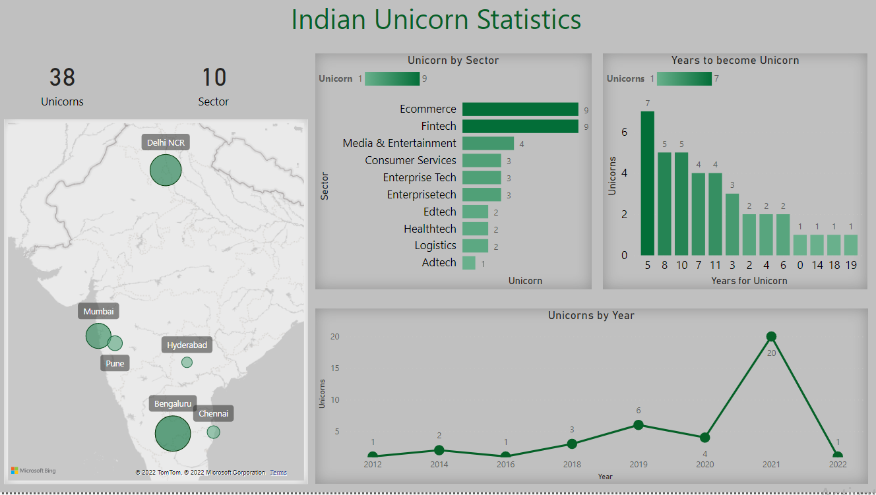  
  
  
Insights:

* All Unicorns from the Last Decades are Founded from 6 states Delhi, Mumbai, Hyderabad, Chennai, Bengaluru and Pune
* Bengaluru Leads by generating 13 Unicorns in 8 different sectors
* Pune Stands at last with only generating 1 unicorn
* 2020 and 2021 two years cumulatively generated 24 unicorn when combined with all other years generated only 14
* Ecommerce and Fintech Lead with 9 unicorn in each sectors
* Data says On an average it takes 7.4 years required to became a unicorn for a company